
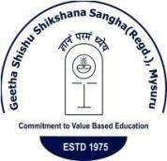
NEWS LETTER ODD SEMESTER 2019
GeethaShishuShikshana Sangha®

GSSS INSTITUTE OF ENGINEERING & TECHNOLOGY FORWOMEN
(AffiliatedtoVisvesvarayaTechnologicalUniversity,Belgavi,&approvedbyAICTE,NewDelhi)
K R S Road, Metagalli, Mysuru
Accredited with Grade ‘A’ by NAAC

DEPARTMENT OF ELECTRICAL & ELECTRONICS ENGINEERING

IEEE PES & ISLE

ABOUT THE DEPARTMENT:

Department of EEE was started in the year 2003, with an intake of 60 students. Strength of the department lies in the teaching and technical staff. The department has full-fledged laboratories as prescribed by VTU syllabus with modern equipment’s. The department has IEEE-PES and ISLE student chapters which conducts many activities throughout the academic year like Industrial visits, technical talks, skill enhancement programs and other co-curricular activities. Staff members are active in research work and have published research papers in reputed journals.

VISION

To be recognized as a premier department producing globally competitive technical Professionals with value based education in the field of electrical engineering committed to social and ethical values.

MISSION
- M1: To provide students with excellent academic ambience for solving problems in Electrical engineering.

- M2: To provide training programs which bridges the gap between academia and industry.

- M3: To provide an environment to carry out research activities in Electrical engineering field which serves the requirements of industry & society.

- M4: To help in building capabilities for excellent energy management and to explore Non-conventional energy sources.

CONTACT US:
Website:http://www.geethashishu.in
Phone Number:0821-2457305/1131
E-mail:hodeee@gsss.edu.in

DEPARTMENTAL ACHIEVERS:

PLACEMENTS:

Sl No. | Name Of The Student | Photo | Company Placed | Package
1 | GAGANA M C | 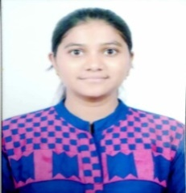 | JUNIPER NETWORKS | 11 LPA
2 | GAGANA M C | 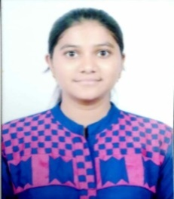 | TCS | 3.5LPA
3 | GAGANA M C | 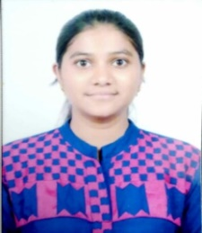 | ACCENTURE | 4.5LPA
4 | A N S VAIBHAVI | 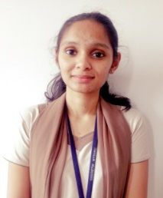 | ACCENTURE | 4.5LPA
5 | A N S VAIBHAVI | 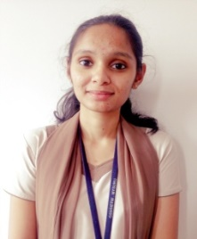 | E&Y (ERNST & YOUNG) | 3.61 LPA
6 | FATIMA DUHA | 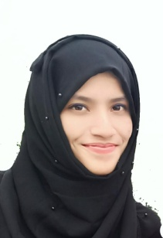 | ACCENTURE | 4.5LPA

7 | FATIMA DUHA |  | L&T TECHNOLOGY SERVICES | 4 LPA
8 | KUSUMA C | 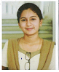 | JUNIPER NETWORKS | 11 LPA
9 | ANUSHA U | 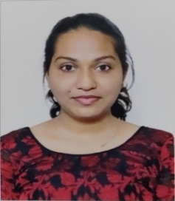 | ACCENTURE | 4.5LPA
10 | BHOOMIKA T S | 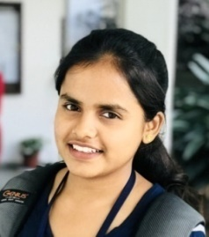 | ACCENTURE | 4.5LPA
11 | CHETHANA M | 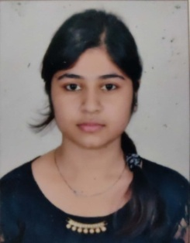 | Accenture | 4.5LPA
12 | KSHEMA S | 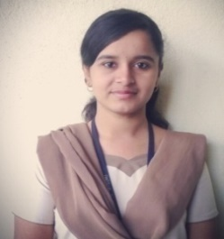 | Accenture | 4.5LPA

13 | MEGHASHREE N R | 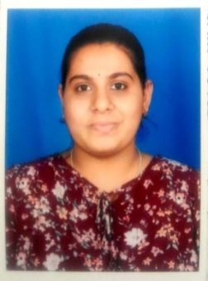 | ACCENTURE | 4.5LPA
14 | NIHARIKA A R | 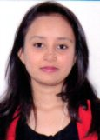 | ACCENTURE | 4.5LPA
15 | POOJA N K | 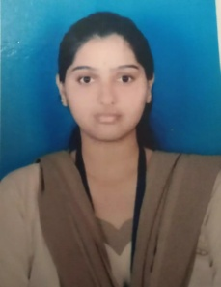 | ACCENTURE | 4.5LPA
16 | POOJA S | 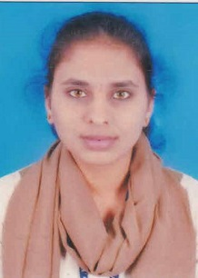 | ACCENTURE | 4.5LPA
17 | PRIYANKA H A | 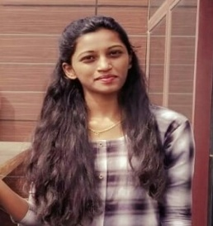 | ACCENTURE | 4.5LPA
18 | RANJITHA G K | 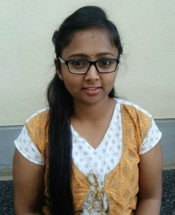 | ACCENTURE | 4.5LPA
19 | SHALINI S | 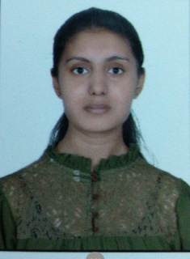 | ACCENTURE | 4.5LPA
20 | UMADEVI R | 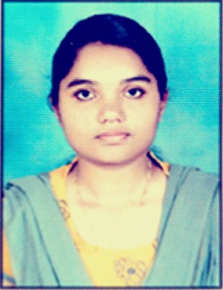 | ACCENTURE | 4.5LPA
21 | SHALINI J | 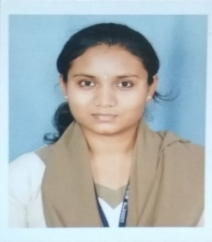 | E&Y (ERNST & YOUNG) | 3.61 LPA
22 | HARSHITHA D R | 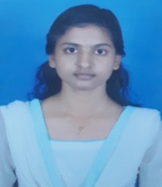 | L&T TECHNOLOGY SERVICES | 4 LPA
23 | MAHEEN SHARIFF | 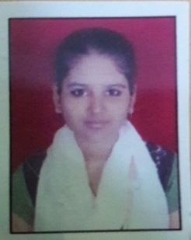 | L&T TECHNOLOGY SERVICES | 4 LPA
24 | PREETHU K | 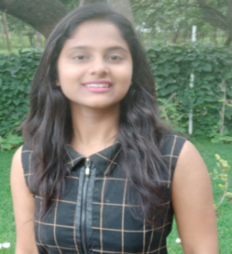 | L&T TECHNOLOGY SERVICES | 4 LPA
25 | TEJASWINI B | 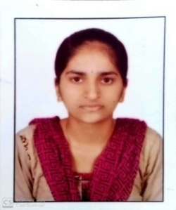 | L&T TECHNOLOGY SERVICES | 4 LPA
26 | UZMA KOUSAR | 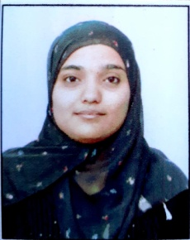 | L&T TECHNOLOGY SERVICES | 4 LPA
27 | SHWETHA N | 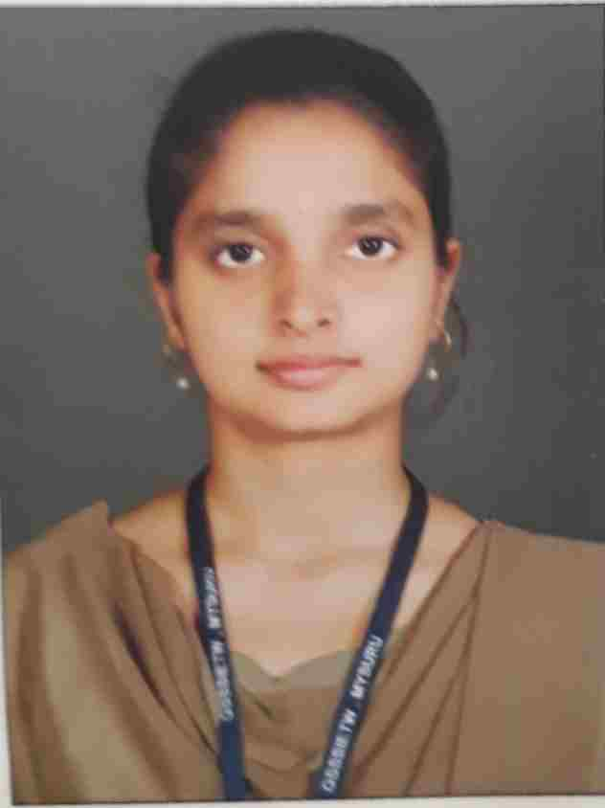 | TCS | 3.5LPA
28 | KUSUMA C |  | IBM | 4.5LPA
29 | NAGAPOOJA P | 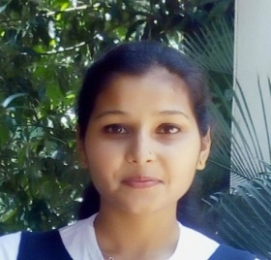 | IBM | 4.5LPA
30 | BI BI HAZIRA | 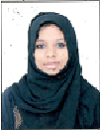 | HERAIZEN | 3LPA

6th SEMESTER
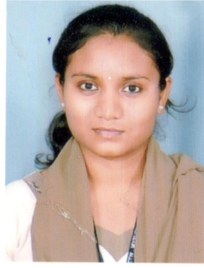
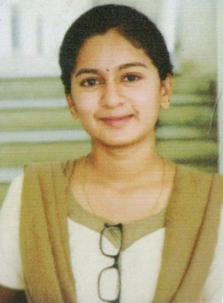
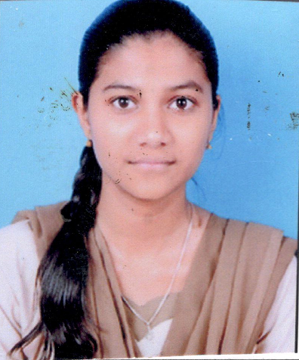 Topper 1 Topper 2 Topper 3

GAGANA M C | KUSUMA C | SHALINI J
89.30% | 87.10% | 84.80%

4thSEMESTER
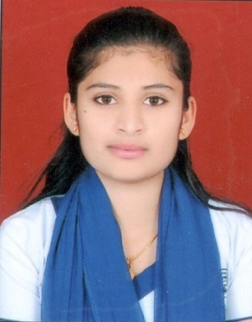
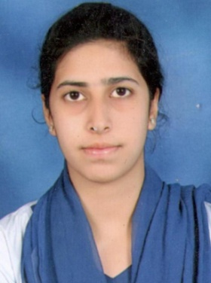
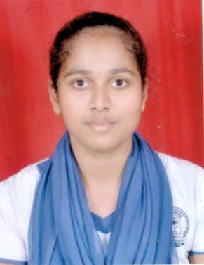
Topper 1 Topper 2 Topper 3

TEJASWINI H | ZEBA NAVAL | SHRUTHI G N
88.10% | 87.90% | 83.50%

2ndSEMESTER
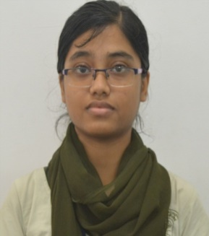
Topper 1 Topper 2Topper 3
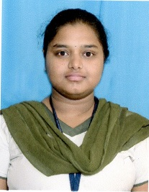
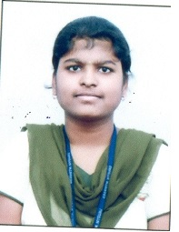

TRINAKSHI MANNA | KEERTHANA G C | SUMA B D
91.12% | 88.12% | 82.5%

STUDENT ACHIEVMENTS:

- DEEPIKA D R, ANANYA Y H, SAHANA G, AMULYA S (III Sem )
Participatedin state level technical fest “AVAGAMAH” organized by dept. of EEE, ATME, Mysuru, on 14th Nov 2019
- SUMA B K, SHREELAKSHMI, POOJA P, YASHASWINI B URS, VARSHA T D, SINDHU S,URMILA M, BHAVEENA M, UMA MAHESHWARI S, LAVANYA G & ANUSHA K (V Sem) participated in “State level Hackathon on Save Farming, Save Forest, Save India” organized by dept. of EEE, VVCE, Mysuru from 12th to 13th Nov2019.
- RAKSHA K, TINU TOM, VANDANA S, MEGHANA S, MADHU S T, DIVYA ARADHYA, SOUNDARYA P (III Sem) participatedin workshop on “Big data in PRAGYATHA-2019” organized by the startup street, MCE, Hassan from 8th to 10th Nov2019.
- APOORVA K, KSHEMA S, KANNIKA C T, A N S VAIBHAVI (VIISem) participated in workshop on “Big data in PRAGYATHA-2019” organized by the startup street, MCE, Hassan from 8th to 10th Nov2019.
- POOJA N K, HARSHITHA D R, ARPITHA S(VIISem) participated in 3 days “All India student YPIE Congress” held in Global Academy of Technology, Bangalore under IEEE student chapter from 17th to 19th Oct2019.
- RAKSHA K, TINU TOM, VANDANA S, AASHRITHA, NANDANA R, DIVYA N (III Sem) participated in two days Technical event “PANCHATANTRA-2019” organized by dept. of Mechanical Engineering, VVCE, Mysuru, on 18th& 19th Oct2019.

- DEEPIKA D R, SHREE TULASI of 3rdsem has secured 1st prize in Technical Quiz & Poster Presentation events, in “EXOUSIA 2019” - An Inter Collegiate Technical Fest,organized by EEE department, in association with ISLE Student Chapter, GSSSIETW, Mysuru held on 22ndNov 2019.

- PRIYANKA M K AND SUPRITHA of ^{7th}sem has secured 1st prize in Tech Charades event, in “EXOUSIA 2019” - An Inter Collegiate Technical Fest,organized by EEE department, in association with ISLE Student Chapter, GSSSIETW, Mysuru, held on 22ndNov 2019.

- KANNIKA C T AND APOORVA K of ^{7th}sem has secured 2nd prize in Tech Charades event, in “EXOUSIA 2019” - An Inter Collegiate Technical Fest,organized by EEE department, in association with ISLE Student Chapter, GSSSIETW, Mysuru, held on 22ndNov 2019.

FACULTY ACHIEVMENTS:

Dr.P S PUTTASWAMY

- Organized one day Inter Collegiate Technical FestEXOUSIA 2019” In association with ISLE Student Chapter, in Department of EEE, GSSSIETW, Mysuru,on 22nd November 2019.
- Served as Jury Member for the Inter College Mini Project Expo-2019 organized by IETE Students Forum, GSSSIETW, Mysuru, on 13th November 2019.
- Attended one day 2nd Inter National seminar on Research and Innovation in Engineering and Technology (ISRIET), organized by GSSSIET, Mysuru on 16th December 2019.

Dr. LIKITH KUMAR M V
- Attended one day 2nd Inter National seminar on Research and Innovation in Engineering and Technology (ISRIET), organized by GSSSIET, Mysuru on 16th December 2019.
- Organized one day Inter Collegiate Technical FestEXOUSIA 2019” In association with ISLE Student Chapter, in Department of EEE, GSSSIETW, Mysuru,on 22nd November 2019.
- Attended 5 days’ workshop on “Recent development in renewable energy sources and conversion system for ON/OFF grid applications, organized by MCE, Hassan, from 9th to 14th December 2019.
- Attended National Level Symposium on Smart Grid, organized by CESC, Mysuru and KEB Engineering Association Zonal Centre Mysuru, on 23rd August 2019.
- Attended 5 days faculty development program on “RECENT TRENDS AND APPLICATIONS OF HIGH VOLTAGE” organized by Department EEE, GSSSIETW, Mysuru, from 27th to 31st July 2019.

ASHWINI K R

- Attended one day 2nd Inter National seminar on Research and Innovation in Engineering and Technology (ISRIET), organized by GSSSIET, Mysuru on 16th December 2019.
- Attended 3 days’ workshop on “Recent trends in Electric Vehicle Technology” at St. Joseph College of engineering, Mangalore, from 12th to 14th December 2019.
- Attended 5 days faculty development program on “RECENT TRENDS AND APPLICATIONS OF HIGH VOLTAGE” organized by Department EEE, GSSSIETW, Mysuru, from 27th to 31st July 2019.

JAGADESH N
- Attended one day 2nd Inter National seminar on Research and Innovation in Engineering and Technology (ISRIET), organized by GSSSIET, Mysuru on 16th December 2019.
- Organized VTU TEQIP 1.3 Sponsored 5 day Faculty Development program on “RECENT TRENDS AND APPLICATIONS OF HIGH VOLTAGE”(A step towards green environment) – Under IQAC, in Department of EEE, GSSSIETW, Mysuru,from 27th to 31st July 2019.
- Organizedone day Industrial Visit to “ SubhashKabini Power Coroporation Limited” (SKPCL) Kabini Dam Site, Beechanahalli, H D Kote taluk, Mysurufor the students of 3rd semester, on 04/11/2019.
- Organized one day Inter Collegiate Technical FestEXOUSIA 2019” In association with ISLE Student Chapter, in Department of EEE, GSSSIETW, Mysuru,on 22nd November 2019.

SHILPASHRI V N

- Attended one day 2nd Inter National seminar on Research and Innovation in Engineering and Technology (ISRIET), organized by GSSSIET, Mysuru on 16th December 2019.
- Attended 5 days faculty development program on “RECENT TRENDS AND APPLICATIONS OF HIGH VOLTAGE” organized by Department EEE, GSSSIETW, Mysuru, from 27th to 31st July 2019.

DIVYA S
- Attended one day 2nd Inter National seminar on Research and Innovation in Engineering and Technology (ISRIET), organized by GSSSIET, Mysuru on 16th December 2019.

- Attended 5 days faculty development program on “RECENT TRENDS AND APPLICATIONS OF HIGH VOLTAGE” organized by Department EEE, GSSSIETW, Mysuru, from 27th to 31st July 2019.

CHAITRASHREE S R

- Attended one day 2nd Inter National seminar on Research and Innovation in Engineering and Technology (ISRIET), organized by GSSSIET, Mysuru on 16th December 2019.

- Attended 5 days faculty development program on “RECENT TRENDS AND APPLICATIONS OF HIGH VOLTAGE” organized by Department EEE, GSSSIETW, Mysuru, from 27th to 31st July 2019.

CHETHAN H R

- Attended one day 2nd Inter National seminar on Research and Innovation in Engineering and Technology (ISRIET), organized by GSSSIET, Mysuru on 16th December 2019.
- Attended workshop on “Virtual Labs” at A T M E College of Engineering, Mysuru, on 26th October 2019.
- Attended 5 days faculty development program on “RECENT TRENDS AND APPLICATIONS OF HIGH VOLTAGE” organized by Department EEE, GSSSIETW, Mysuru, from 27th to 31st July 2019.

BHARATHESH PATEL N

- Attended one day 2nd Inter National seminar on Research and Innovation in Engineering and Technology (ISRIET), organized by GSSSIET, Mysuru on 16th December 2019.
- Attended 5 days faculty development program on “RECENT TRENDS AND APPLICATIONS OF HIGH VOLTAGE” organized by Department EEE, GSSSIETW, Mysuru, from 27th to 31st July 2019.

KISHORINI M C

- Attended one day 2nd Inter National seminar on Research and Innovation in Engineering and Technology (ISRIET), organized by GSSSIET, Mysuru on 16th December 2019.
- Attended 5 days faculty development program on “RECENT TRENDS AND APPLICATIONS OF HIGH VOLTAGE” organized by Department EEE, GSSSIETW, Mysuru, from 27th to 31st July 2019.

GIRISHA K M
- Attended one day 2nd Inter National seminar on Research and Innovation in Engineering and Technology (ISRIET), organized by GSSSIET, Mysuru on 16th December 2019.
- Attended 5 days faculty development program on “RECENT TRENDS AND APPLICATIONS OF HIGH VOLTAGE” organized by Department EEE, GSSSIETW, Mysuru, from 27th to 31st July 2019.

SHRAVYA J
- Attended one day 2nd Inter National seminar on Research and Innovation in Engineering and Technology (ISRIET), organized by GSSSIET, Mysuru on 16th December 2019.
- Attended 5 days faculty development program on “RECENT TRENDS AND APPLICATIONS OF HIGH VOLTAGE” organized by Department EEE, GSSSIETW, Mysuru, from 27th to 31st July 2019.

Technical Talk/Workshops Conducted:

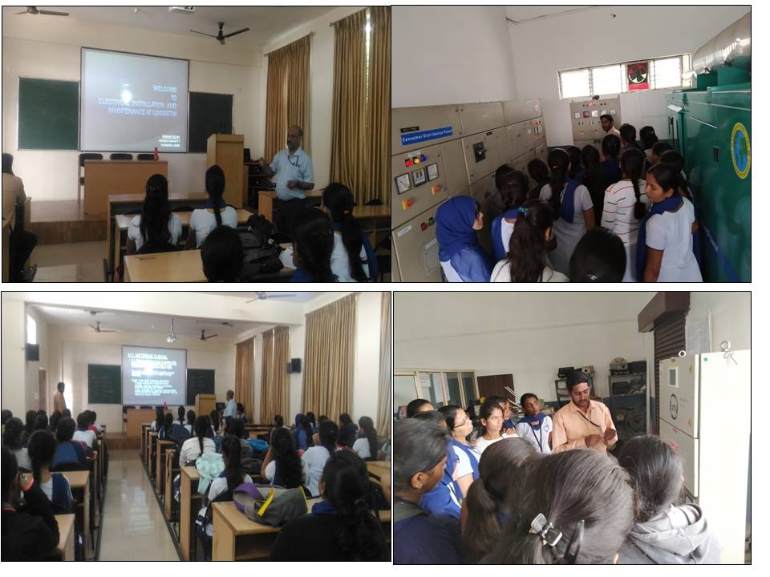
- Technical Talk on “Electrical Installation and maintenance at GSSSIETW”

Technical talk on “Electrical Installation and maintenance at GSSSIETW” was delivered bySri.PrabhuSwamy.V, Foreman, EEE, GSSSIETW for 5th semester students on 17th August 2019

- A Technical talk on “Awareness on NPTEL Courses”
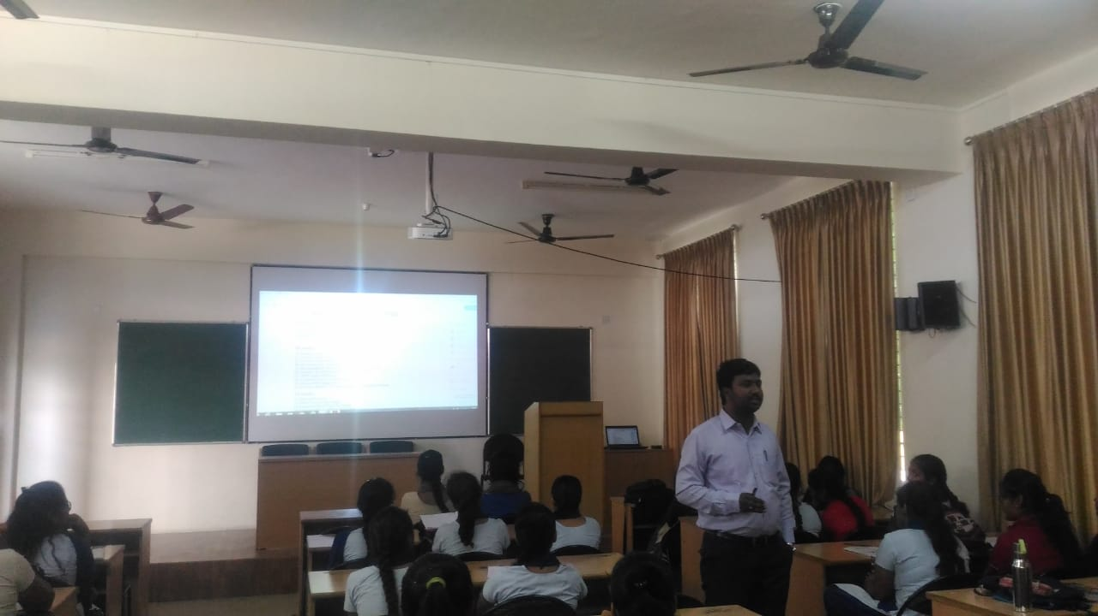

Technical Talk on “Awareness on NPTEL” for 3rd, 5th&7th Semester Students by
Mr. Chethan H R, Assistant Professor, Dept of EEE, GSSSIETW, Mysuru, on 24th Aug 2019.

- Technical Talk on "Intelligent lighting controls” & workshop on “Power factor correction on lighting loads”
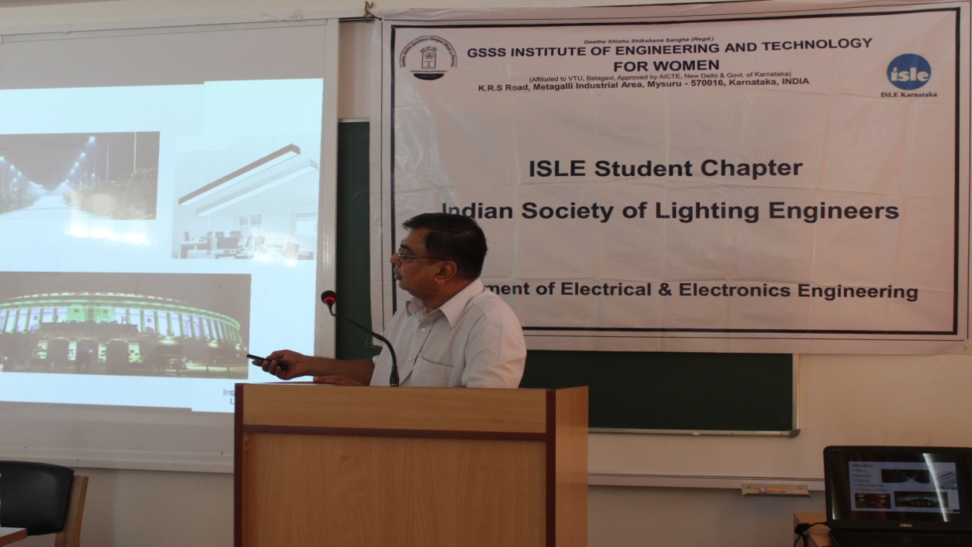

Technical Talk on "Intelligent lighting controls” & workshop on “Power factor correction onlighting loads” under ISLE student chapter for 5th and 7th Semester students by Mr.Ravi, Chief Technology Officer Asian Electronics Ltd. on 6th September 2019.

Three Day Workshop on “C and C++ coding”
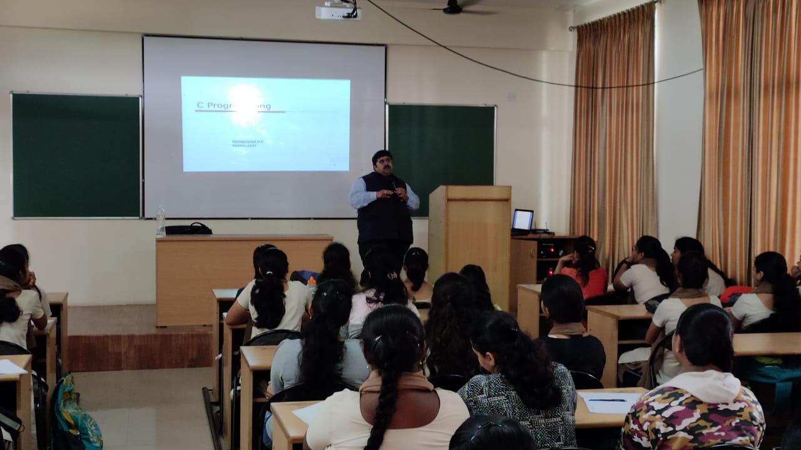

Three Days Workshop on “C and C++ coding” for 7thSemester students, by Ramparasd H C, Head Research-learning and development. 10 Seconds, Bangaluru,
From25th to 27th September 2019.

DEPARTMENTAL ACHIEVMENTS:
- Faculty Development Program Conducted Under VTU TEQIP 1.3 Sponsored “RECENT TRENDS AND APPLICATIONS OF HIGH VOLTAGE”

The department of Electrical and Electronics Engineering of GSSS Institute of Engineering and Technology for Women, Mysuru had organized VTU TEQIP 1.3 Sponsored 5 day Faculty Development program on “RECENT TRENDS AND APPLICATIONS OF HIGH VOLTAGE”(A step towards green environment) – Under IQACin association with
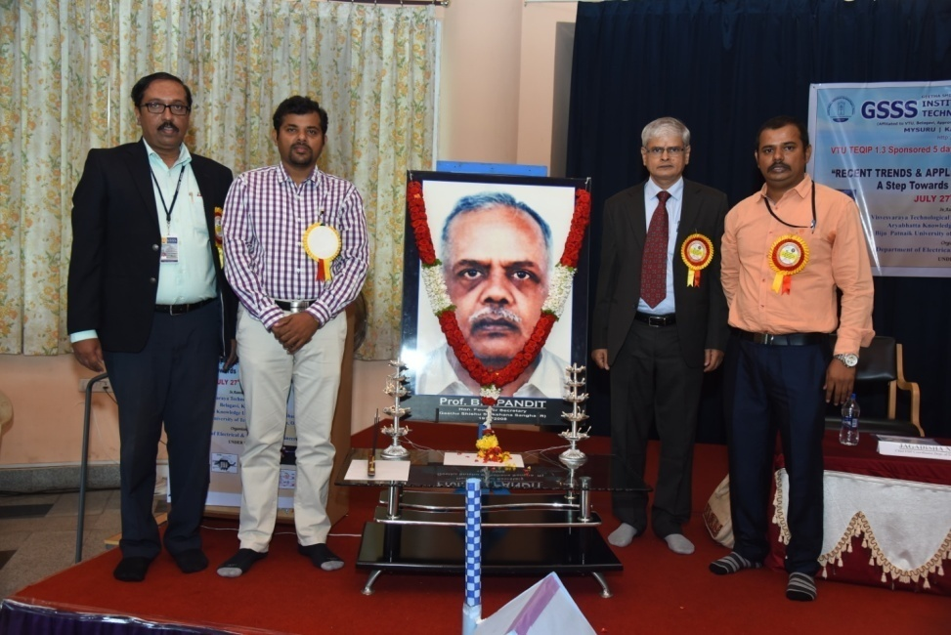
VTU Belgavi, Aryabhata Knowledge University, Patna, Bihar & Biju Patnailk University of Technology, Rourkela, Orissa from 27th to 31st July 2019.
Dr. M Shivakumar, Principal, GSSSIETW, Mysuru,Dr. SankarasanMohapatro,School of Electrical Sciences, IIT Bhubaneshwar,Dr. S. Sekar, Ex GM,BHEL,and MrJagadisha N Chief Coordinator VTU TEQIP FDP.

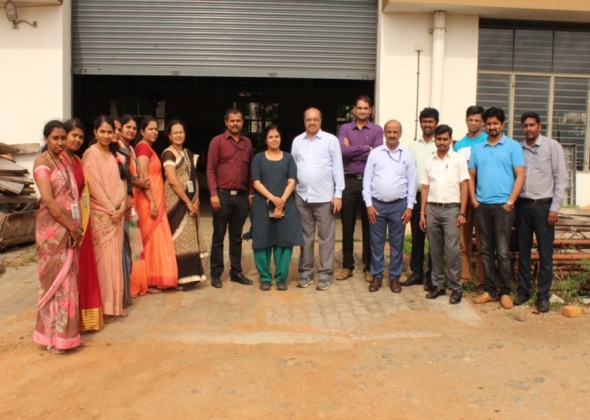
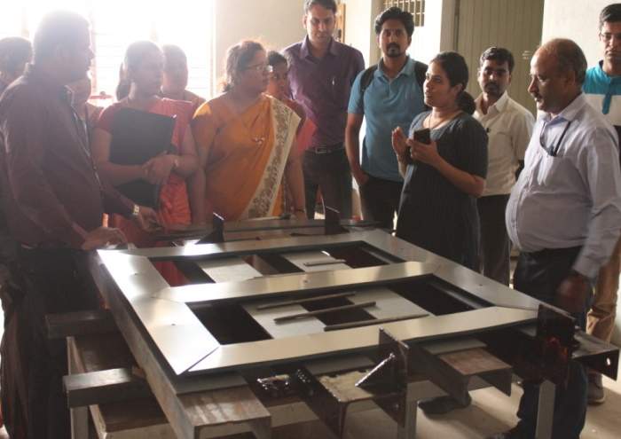
Industrial Visit to “Power System Controls”, Ilwala Industrial Area, Mysuru
The participants were taken for a visit to “Power System Controls” – A Transformer Manufacturing company in the Ilawala Industrial area in the afternoon session.

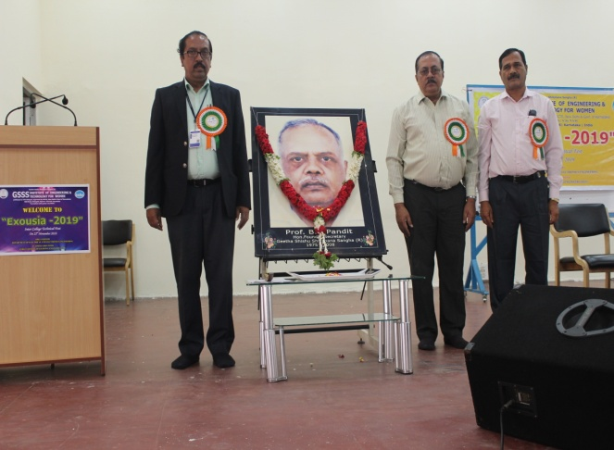
- “EXOUSIA 2019” - An Inter Collegiate Technical Fest In association with ISLE Student Chapter, GSSSIETW, Mysuru
Dr. M Shivakumar, Principal, GSSSIETW, Chief Guest:Sri. M GSathyendra, Secretary, ISLE Karnataka Section and Dr. P S Puttaswamy, Professor and Head, Dept. of EEE, GSSSIETW, Mysuru
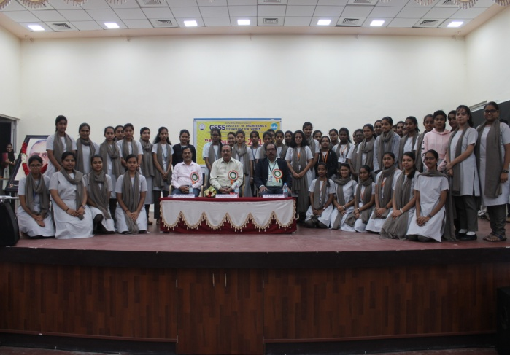
One day Inter collegiate technical fest – “EXOUSIA 2019” in association with ISLE student chapter on 22nd November 2019

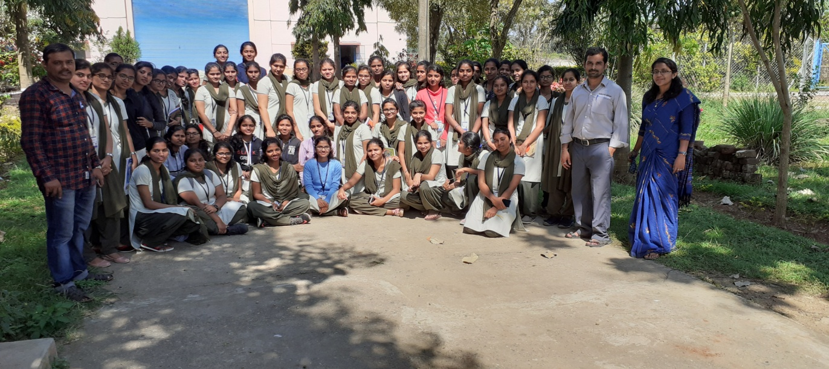
INDUSTRIAL VISITS:
Industrial Visit to “ SubhashKabini Power Coroporation Limited” (SKPCL) Kabini Dam Site, Beechanahalli, H D Kote taluk, Mysuru was arranged for the students of 3rd semester, accompanied by the staff members MrJagadisha N and Ms. Kishorini M Con 04/11/2019.
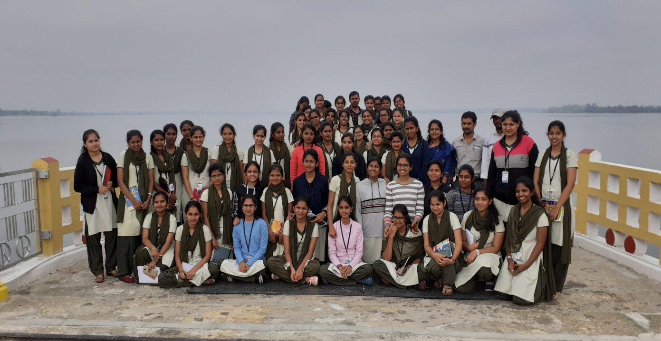

EDITED BY:
GIRISHA K M
Assistant professor
Department of EEE
GSSSIETW, Mysuru.

